Sukkur IBA University


Data Structure Algorithm

Name: Tariq Mehmood
CMS ID: 023-23-0127
Semester: 3rd
Section: E
Submitted by: Sir Riaz Hussain
Lab No: 06

Q1:

public class Q1 {
public static void main(String[] args) {
int[] arr={1,2,3,4,5};
int ans=BS(arr, 0, arr.length-1, 51);
if(ans != -1){

System.out.println("Found at index: "+ans);
}else{
System.out.println("Not Found...");
}
}

public static int BS(int[] arr, int start,int end, int target){
if(start > end){
return -1;
}

int mid = start+(end-start)/2;
if(arr[mid]== target){
return mid;
}
if(arr[mid] > target){
return BS(arr, start, mid-1, target);
} else{
return BS(arr, mid+1, end, target);
}
}
}

Q2
public class Task2{
public int Fact(int number){
if(number==0|| number==1){
return 1;
}
else{
return number*Fact(number-1);
}

}
public static void main(String[] args) {
Task2 fact=new Task2();
int n=5;
System.out.println("The Factorial of "+n+" : "+fact.Fact(n));

}
}
Q3:

public class Task3{
public static void Fibonacci(int a, int b, int n){
if(n<1) {
return;
}
System.out.print(a+" ");
Fibonacci(b, a+b, n-1);

}

public static void main(String[] args) {

Fibonacci(0, 1, 7);
}
}
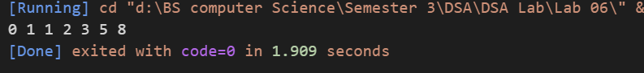
Q4
import java.util.Stack;

public class Q4 {
public static void main(String[] args) {
Stack<Integer> stack= new Stack<>();
stack.push(4);
stack.push(3);
stack.push(2);
stack.push(1);
System.out.println(stack);
stack = reverseStack1(stack);
System.out.println(stack);
reverseStack(stack);
System.out.println(stack);

}
// Function to reverse the stack using recursion
public static void reverseStack(Stack<Integer> stack) {
// Base case: if the stack is empty, return
if (stack.isEmpty()) {
return;
}

// Remove the top element of the stack
int top = stack.pop();

// Recursively reverse the remaining stack
reverseStack(stack);

// Insert the top element at the bottom of the stack
insertAtBottom(stack, top);
}

// Helper function to insert an element at the bottom of the stack
private static void insertAtBottom(Stack<Integer> stack, int element) {
// Base case: if the stack is empty, insert the element
if (stack.isEmpty()) {
stack.push(element);
return;
}

// Remove the top element
int top = stack.pop();

// Recursively insert the element at the bottom
insertAtBottom(stack, element);

// Push the top element back onto the stack
stack.push(top);
}

public static Stack<Integer> reverseStack1(Stack<Integer> stack){
Stack<Integer> s2= new Stack<>();
stackHelper(stack,s2);
return s2;

}
static void stackHelper(Stack<Integer> first,Stack<Integer> second){
if(first.isEmpty()){
return;
}
second.push(first.pop());
stackHelper(first, second);
}
}
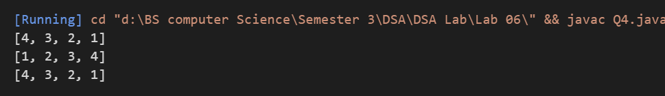
Q5
public class Q5PrintList {
public static void main(String[] args) {

ListNode head = new ListNode(10);
head.next = new ListNode(20);
head.next.next = new ListNode(30);
head.next.next.next = new ListNode(40);

System.out.print("The linked list is: ");
printList(head);
System.out.print("The linked list Reverse is: ");
printReverseList(head);

}

public static void printList(ListNode node) {
if (node == null) {
return;
}
System.out.print(node.val + " ");
printList(node.next);
}
public static void printReverseList(ListNode node) {
if (node == null) {
return;
}
printReverseList(node.next);
System.out.print(node.val + " ");
}
}

class ListNode {
int val;
ListNode next;

ListNode(int val) {
this.val = val;
this.next = null;
}
}
Q7
public class Palindrome{
public static void main(String[] args) {
String s= "racecar";
boolean ans= isPalindrome(s, 0, s.length()-1);
System.out.println(ans);
}
static boolean isPalindrome(String s,int start, int end){
if(start >= end){
return true;
}
if(s.charAt(start) !=s.charAt(end)){
return false;
}
return isPalindrome(s, start+1, end-1);
}
}
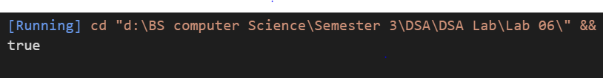

Q8
public class TowersOfHanoi {

public static void solveTowersOfHanoi(int n, char source, char auxiliary, char destination) {
if (n == 1) {
System.out.println("Move disk 1 from " + source + " to " + destination);
return;
}

solveTowersOfHanoi(n - 1, source, destination, auxiliary);
System.out.println("Move disk " + n + " from " + source + " to " + destination);
solveTowersOfHanoi(n - 1, auxiliary, source, destination);
}

public static void main(String[] args) {
int numDisks = 3;
solveTowersOfHanoi(numDisks, 'A', 'B', 'C');
}
}
